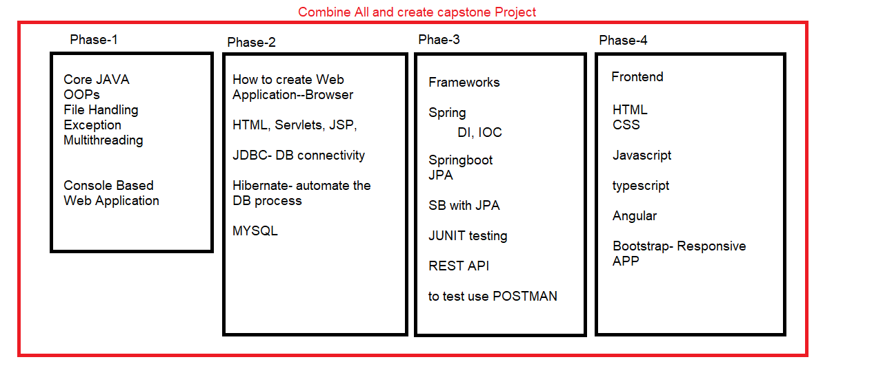

How to implement Capstone

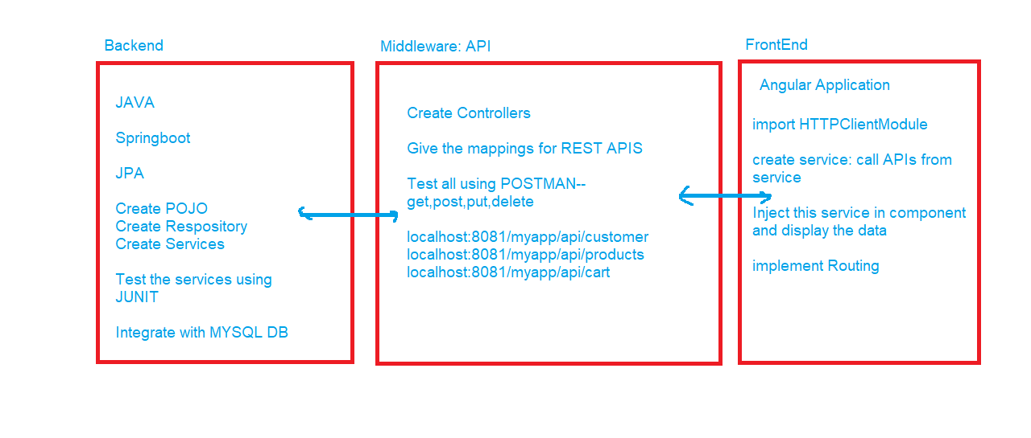

HealthCare: Medicare

Users: 2 users (Admin, Customer)

What Admin can do?

* Login
* Change Password
* Add new Products
* Update/delete products
* Product Enable/Disable

What User can do?

* Registration/ Login
* Update Profile/ change password
* Forgot Password
* Search for Product
* Add product to cart
* Check the selected products
* Confirm the order
* Check order History